**Automobile Spare Parts Shop Automation System (ASPAS)**

**1. Problem Statement**

In today’s fast-paced automobile service industry, small-scale spare parts retailers face several challenges managing their operations manually. These challenges include inefficient inventory management, delayed order processing, poor tracking of sales and vendor information, and an overall lack of integration that leads to operational bottlenecks.

Manual record-keeping systems are error-prone and time-consuming, leading to stockouts or overstocking, delayed order fulfillment, and difficulties in analyzing sales trends or vendor reliability. These inefficiencies ultimately impact customer satisfaction and profitability.

To address these challenges, we propose the development of the *Automobile Spare Parts Shop Automation System (ASPAS)*. This system is designed to automate core business processes, reduce manual effort, enhance operational visibility, and support business growth.

---

**2. Optimal Solution Overview (as per SRS Document v2)**

ASPAS is a comprehensive solution that automates the entire lifecycle of spare parts management, from inventory tracking and reordering to sales processing and vendor management.

Key Functionalities:

Inventory Management: Tracks stock levels by manufacturer and vehicle type, supports search and manual updates.

Automatic Reordering: Automatically generates reorder lists based on weekly sales trends and inventory thresholds.

Sales Processing: Facilitates smooth sales transactions, updates stock, and supports multiple payment modes.

Report Generation: Daily and monthly sales data presented in reports and graphs, exportable as PDF/Excel.

Vendor Management: Maintains vendor details and integrates with reordering logic.

User Management: Implements role-based access with authentication and audit logs.

Non-Functional Strengths:

* High performance and reliability (e.g., <2s transaction processing)

* Scalable architecture

* User-friendly GUI, accessible features

* Integration with barcode scanners, receipt printers, and accounting systems

This system is designed using modern software engineering principles, adheres to industry standards, and ensures secure and reliable operations.

---

**3. Diagram Discussions**

***3.1 Use Case Diagram***

The Use Case Diagram outlines the interactions between various user roles (actors) and the system. It identifies what each user can do within the system.

**Actors:**

Shop Owner: The primary administrator with access to all system functionalities including reports, vendor and user management.

Employee: Restricted user who can access sales processing and inventory viewing features.

**Key Use Cases:**

Manage Inventory: Add, update, and view parts available in the shop.

Process Sales: Register a sale, generate a receipt, and update the stock.

Generate Reports: Generate daily revenue summaries and trend-based sales analytics.

Manage Vendors: Maintain vendor information and evaluate supply history.

Manage Users: Create and manage user accounts and access roles.

Each use case contains detailed scenarios, including preconditions (e.g., user login), step-by-step interaction flows, alternate flows (e.g., handling out-of-stock scenarios), and postconditions (e.g., updated inventory).

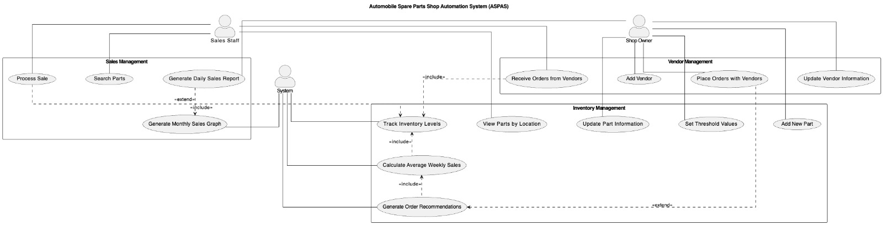

***3.2 Data Flow Diagram (DFD Level 0)***

The Level 0 Data Flow Diagram presents the system as a single process block interacting with external entities and major data stores. It offers a high-level overview of the flow of information.

**External Entities:**

Customer: Initiates the purchase and receives the receipt.

Vendor: Supplies products and receives reorder notifications.

Shop Owner: Oversees all operations and uses reporting features.

**Process:**

* The central process, "Automate Spare Parts Shop," interacts with all entities and performs key functions: recording sales, updating inventory, processing reports, and generating reorders.

**Data Stores:**

Inventory Database: Stores product details, current stock, and manufacturer data.

Sales Log: Tracks all transactions including timestamps, product details, and payment status.

Vendor Database: Keeps vendor contact info and previous orders.

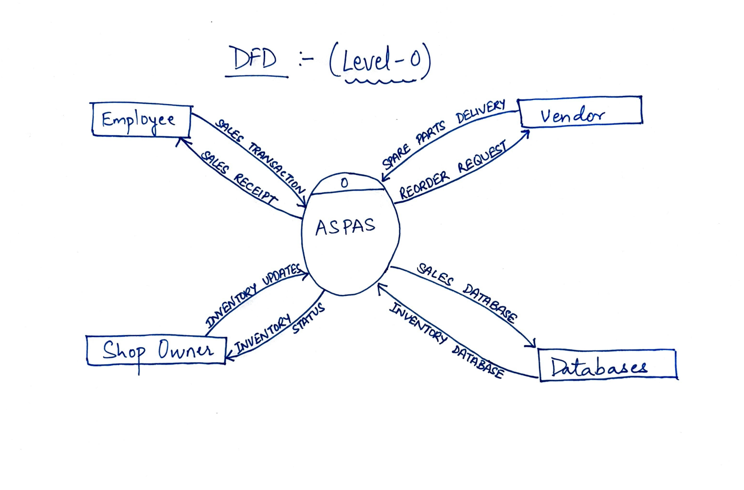

***3.3 Use Case Descriptions***

Each use case is described in full detail based on the uploaded document.

**Use Case: Manage Inventory**

Actor: Shop Owner, Employee

Pre-condition: User is authenticated

Basic Flow:

1. The user searches for the part by name or manufacturer.

2. View current stock details.

3. Can update quantity or edit details.

Alternate Flow: If a part does not exist, the user is prompted to add a new part.

Post-condition: Inventory database is updated.

**Use Case: Process Sale**

Actor: Employee

Pre-condition: Log in with valid permissions.

Basic Flow:

1. Select product and quantity.

2. System validates stock availability.

3. Payment method selected.

4. Receipt is generated.

5. Inventory is updated and sale is logged.

Alternate Flow: If the item is out of stock, an alert is shown.

Post-condition: Transaction stored in sales log.

**Use Case: Generate Report**

Actor: Shop Owner

Pre-condition: The system contains historical sales data.

Basic Flow:

1. User selects report type and date range.

2. System aggregates data.

3. Report is displayed as table and graph.

4. Option to export as PDF/Excel.

Post-condition: None (report is view-only).

**Use Case: Manage Vendors**

Actor: Shop Owner

Pre-condition: Vendor data exists.

Basic Flow:

1. View existing vendors.

2. Add/edit/delete vendor information.

3. View past reorder history.

Post-condition: Vendor records updated.

***3.4 Supplementary Sketches and Images***

Level 1 DFDs: These break down the main process into smaller sub-processes. For example:

* "Check Inventory Stock"

* "Validate Login Credentials"

* "Create Vendor Order"

* "Generate Daily Report"

Each process shows input/output flows to and from the data stores and external actors.

State Diagrams: The inventory item entity transitions through states:

Available → Low Stock → Reorder Placed→ Out of Stock

* Triggered by sales, manual edits, or reorder generation logic.

Activity Diagrams:

Sales Activity: Start → Select Item → Enter Quantity → Payment → Receipt → End

Vendor Update Activity: Start → Choose Vendor → Modify Details → Save → End

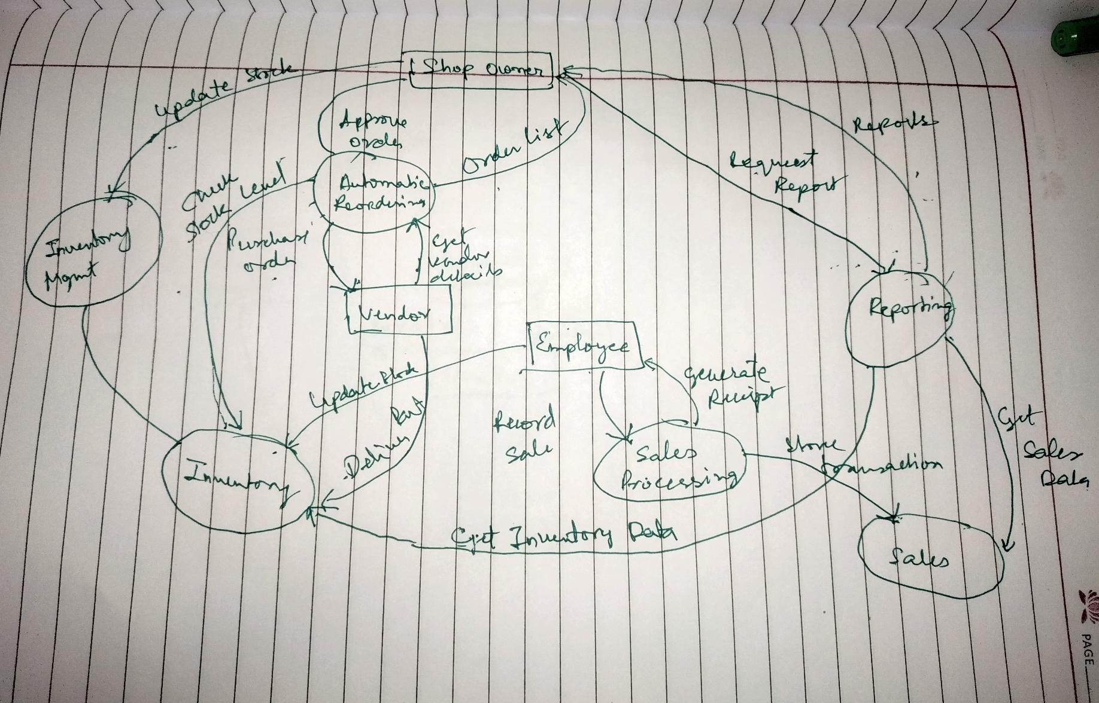

Domain Model Diagram:

The domain model defines the main objects (entities) in the ASPAS system and their relationships. These include:

Product: Identified by product ID, including name, category, price, quantity, and supplier.

Sales: Tied to date and contains line items detailing each product sold.

Vendor: Store name, contact info, and list of supplied parts.

User: Represents shop owners or employees with attributes such as username, role, and access rights.

Inventory: A collection of Products, associated with reorder thresholds.

Relationships are mostly one-to-many: a vendor supplies many products; a sale includes many product entries; a user may perform many sales or inventory actions.

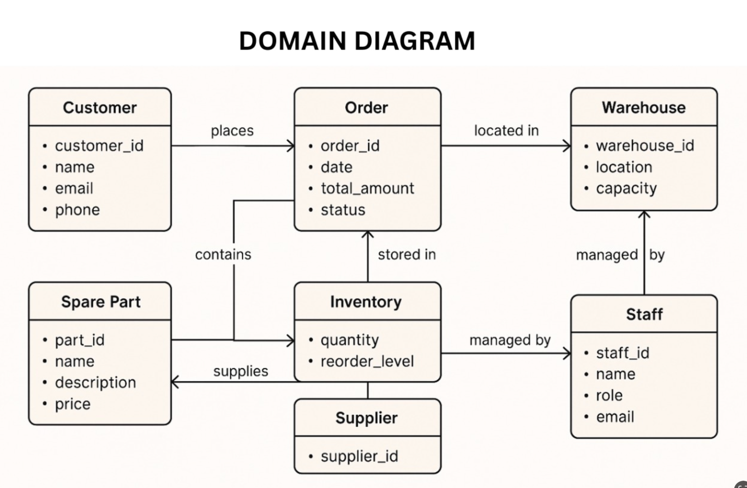

Sequence Diagram:

The sequence diagram captures the dynamic flow of operations during the sales process:

1. Employee initiates the transaction by logging in.

2. The system validates credentials via the Authentication Module.

3. Employee searches for Product → system queries the inventory.

4. Product details are fetched and quantity is confirmed.

5. On checkout, the Payment Processor validates and confirms payment.

6. A Receipt Generator creates the bill.

7. Inventory is updated and Sales Log records the transaction.

The sequence ensures proper coordination between UI, controllers, and backend services.

These diagrams were instrumental during both analysis and implementation phases.

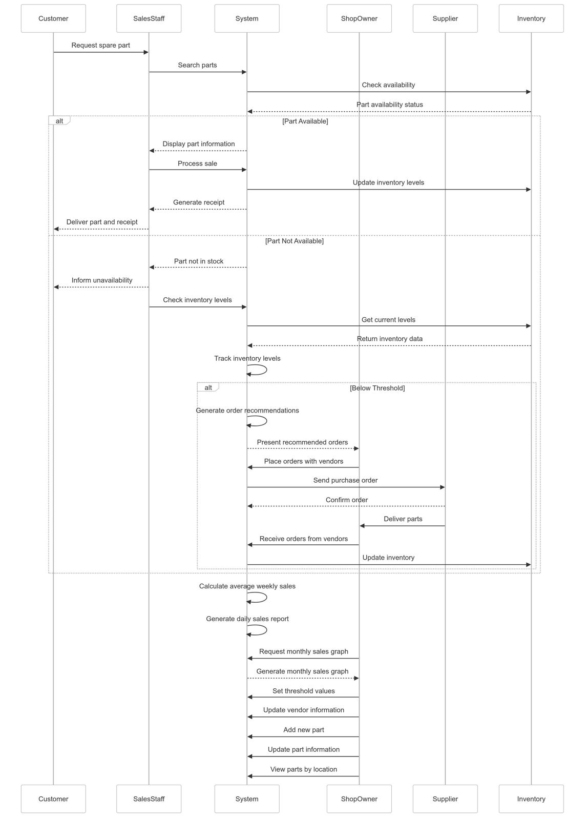

### Class Diagram

The class diagram models the static structure of the system by representing classes, their attributes, and the relationships between them. Key entities include Customer, Order, Inventory, SparePart, and System, each with clearly defined roles. The Order class links customers to specific OrderItems, which in turn reference SpareParts. The Inventory is associated with Warehouse, Rack, and Staff to manage stock levels, while Supplier and Vehicle provide additional context for part compatibility and sourcing. The System class encapsulates core functionalities like generating receipts, tracking inventory, and generating reports. This diagram ensures a clear understanding of how components interact to support the automation of spare parts management.

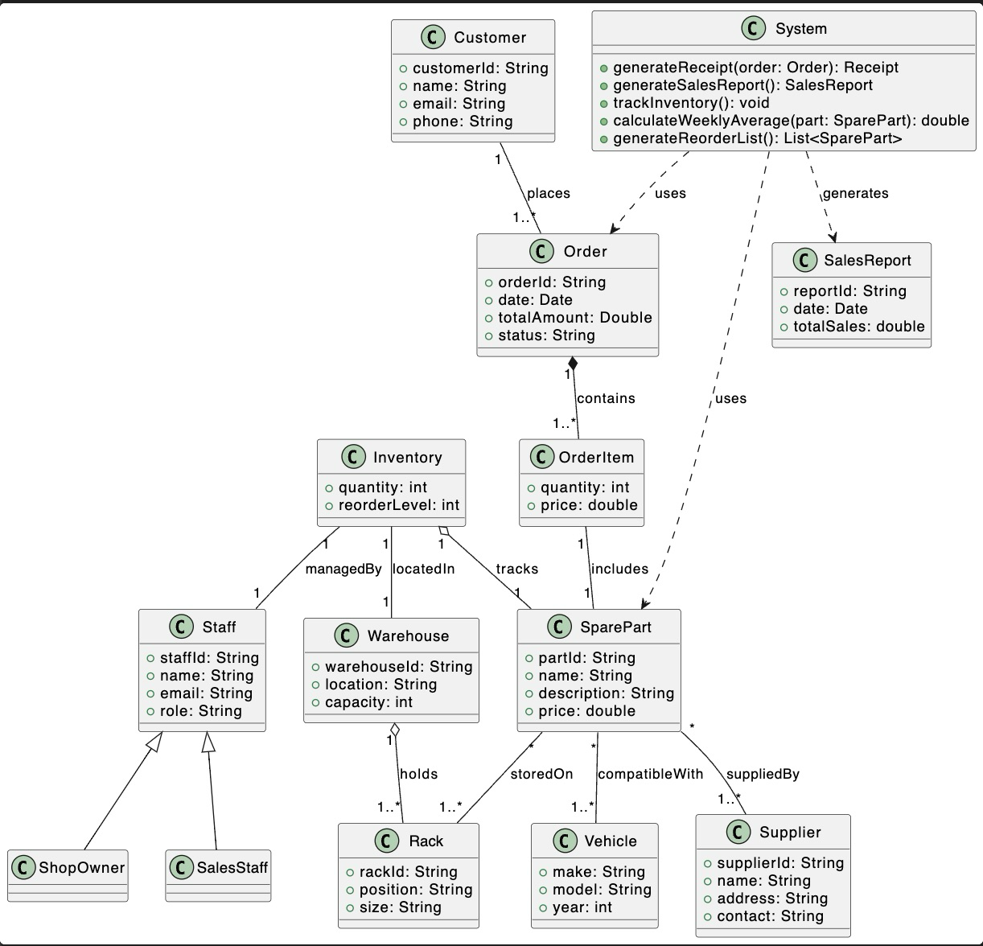

**4. Codebase**

The system utilizes SQLite with five main tables:

* **inventory**: Stores part information and stock levels
* **vendors**: Manages supplier information
* **sales**: Records transaction details
* **users**: Handles authentication and authorization
* **audit_log**: Tracks system activity for security and compliance

The setup_database() function creates these tables if they don't exist and initializes the system with default admin credentials.

### **Authentication and Access Control**

**login_screen()**: Creates a login window where users enter credentials that are verified against the database. Upon successful authentication, the function records the login event in the audit log and launches the appropriate interface based on the user's role.

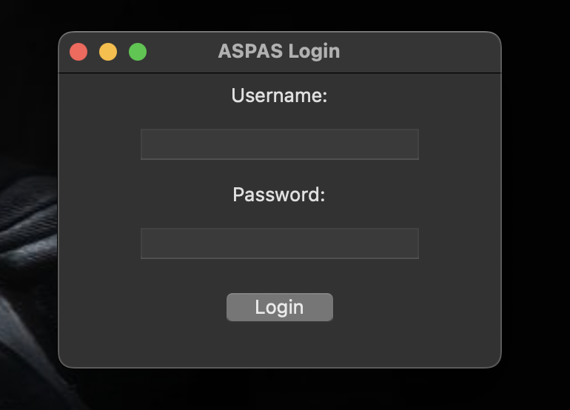

### **ID Generation System**

The system employs specialized ID generation functions for different entities:

**generate_inventory_id()**: Creates unique inventory IDs with the prefix "I-ATIL" followed by random alphanumeric characters.

**generate_vendor_id()**: Creates vendor IDs with the prefix "V-ATIL" and random characters.

**generate_sale_id()**: Creates transaction IDs with the prefix "S-ATIL" for sales tracking.

**generate_audit_id()**: Creates audit log entry IDs with the prefix "A-ATIL" for system event tracking.

### **Inventory Management**

**add_inventory()**: Creates new part entries with generated IDs, validates input parameters, updates the database, logs the action, and refreshes the display.

**delete_inventory()**: Removes selected parts from inventory, maintains an audit trail of deletions, and updates the interface.

**refresh_inventory_table()**: Updates the GUI display with the latest inventory data from the database.

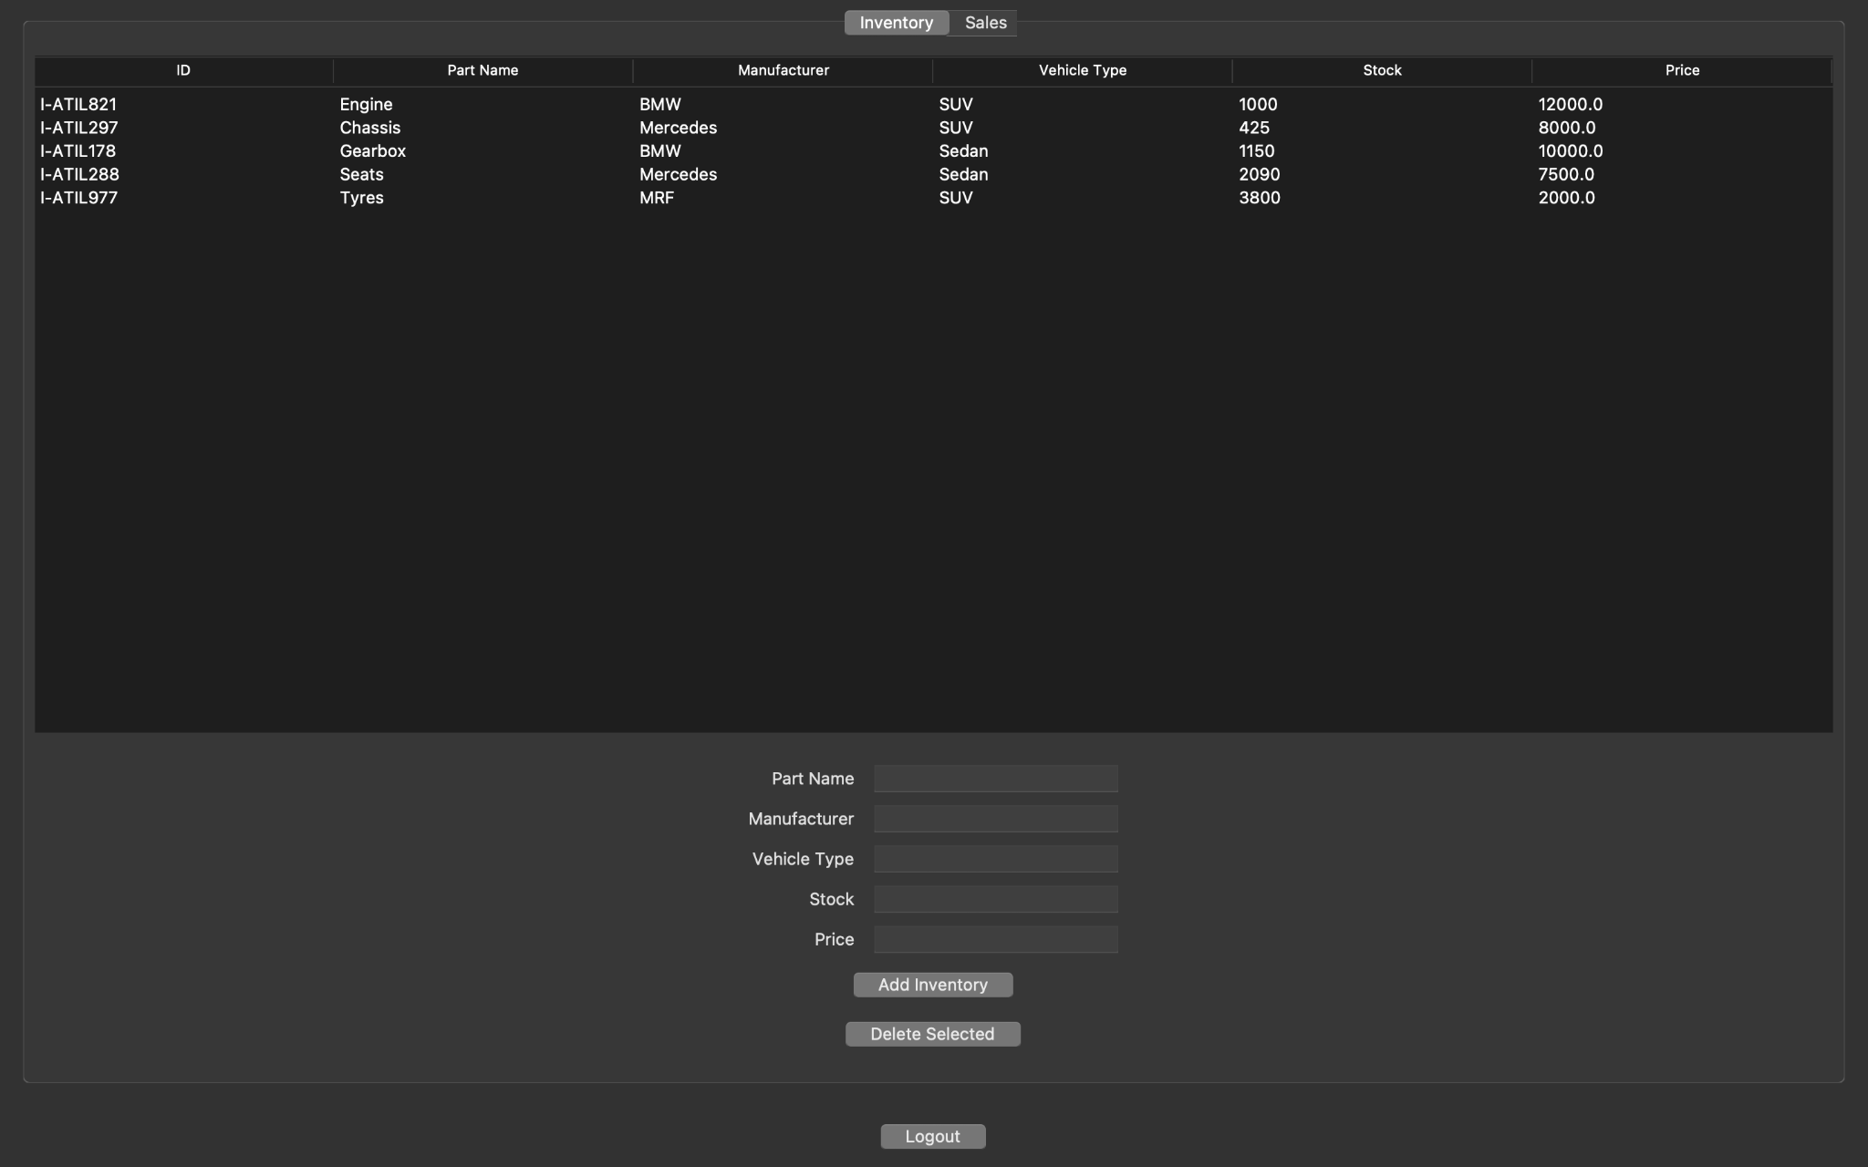

### (Employee Inventory Tab)

### **Auto-Reordering System**

**check_and_auto_order()**: Intelligently monitors inventory levels against thresholds (30% of initial stock). When stock falls below threshold, it automatically triggers the reorder process, updates inventory quantities, creates audit log entries, and notifies users.

### **Sales Processing**

**record_sale()**: Validates stock availability, calculates transaction amounts, updates inventory levels, creates comprehensive sales records, maintains an audit trail, and triggers the auto-order check after each transaction.

**record_sale_from_customer_view()**: Similar to record_sale() but designed for direct customer orders, with appropriate validation and different audit log entries.

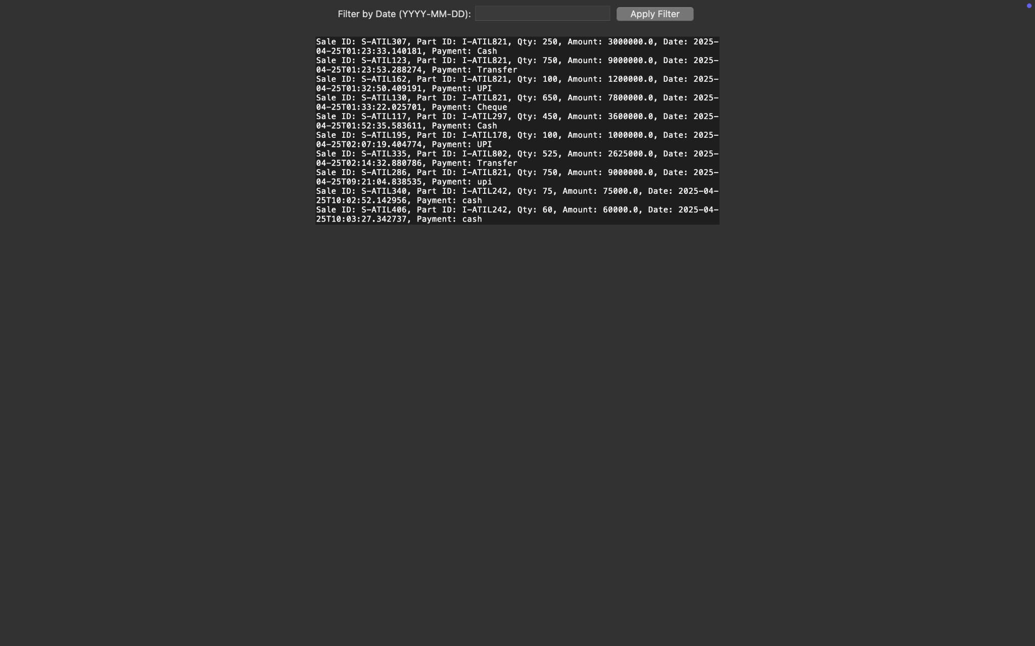(admin sales tab)

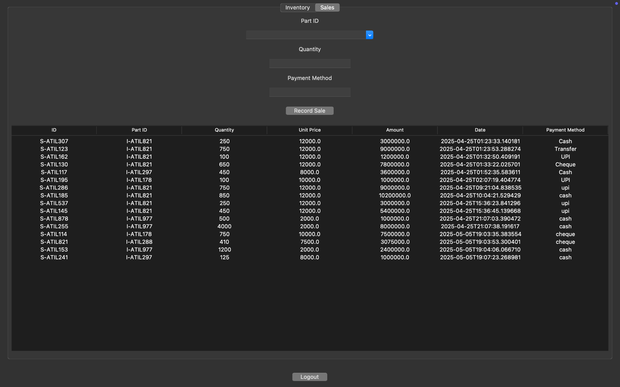(employee sales tab)

### **Vendor Management**

**add_vendor()**: Creates supplier records with unique IDs, stores contact information and associated parts, and maintains an audit trail of vendor additions.

**refresh_vendor_table()**: Updates the vendor management interface with current data.

### **Reporting and Analytics**

**generate_reports()**: Creates filterable sales reports with date-based filtering and detailed transaction view.

**export_monthly_sales_pdf()**: Generates professionally formatted PDF reports of monthly sales data, organized chronologically with relevant totals.

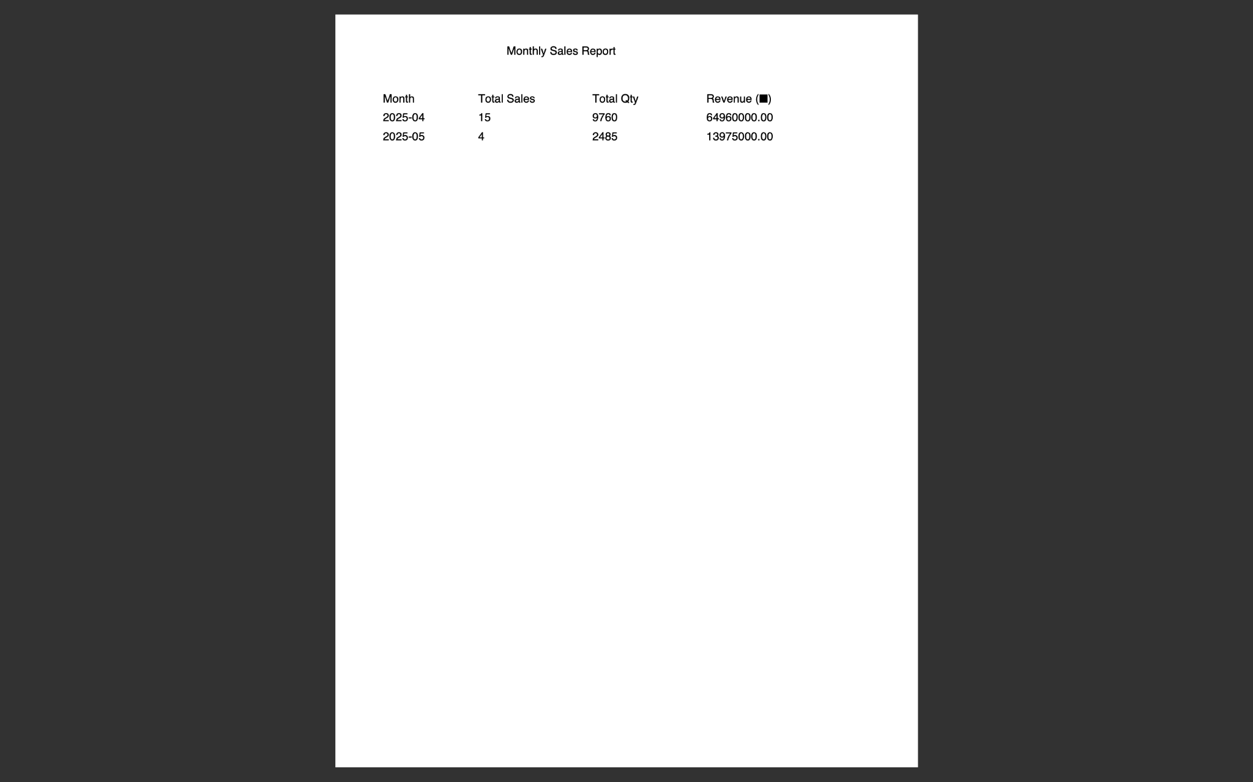(monthly sale report)

**calculate_avg_weekly_demand()**: Analyzes sales data to determine average weekly demand for inventory planning.

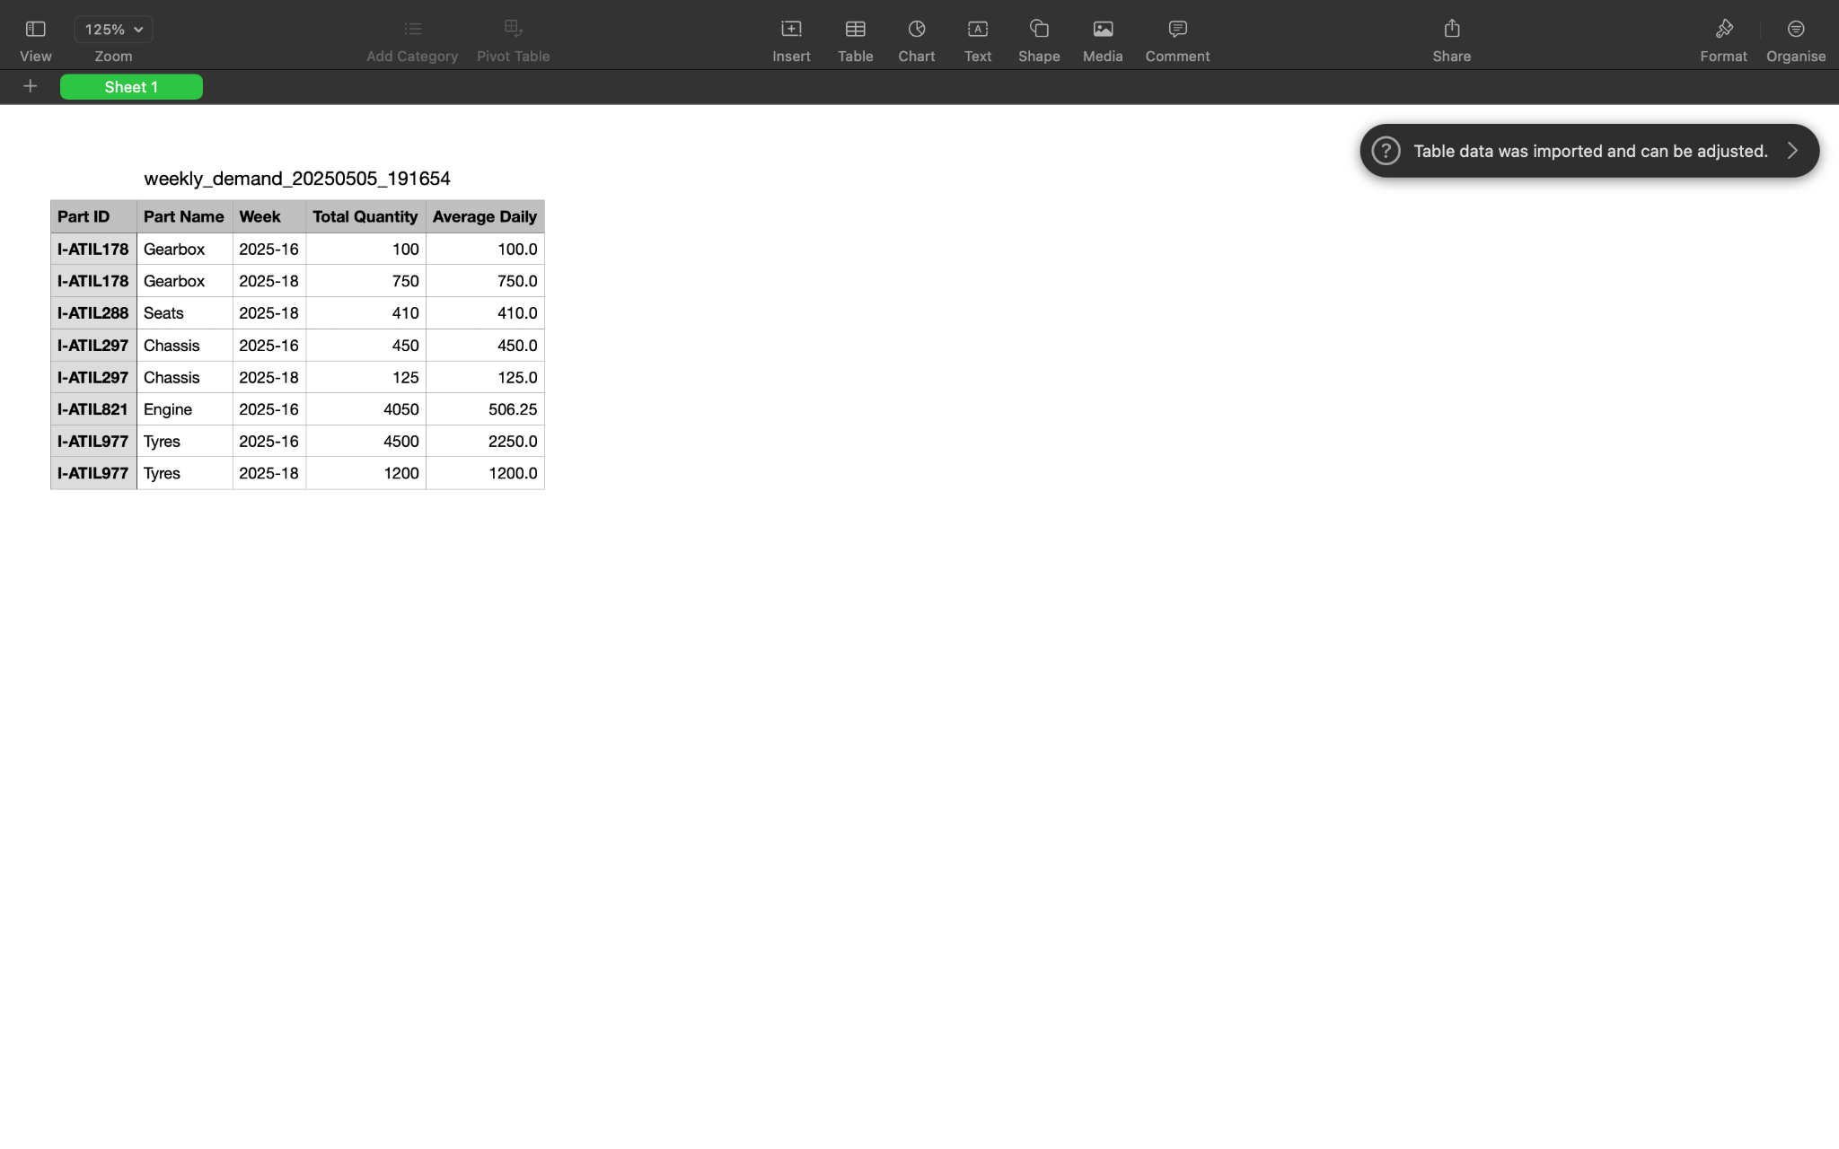

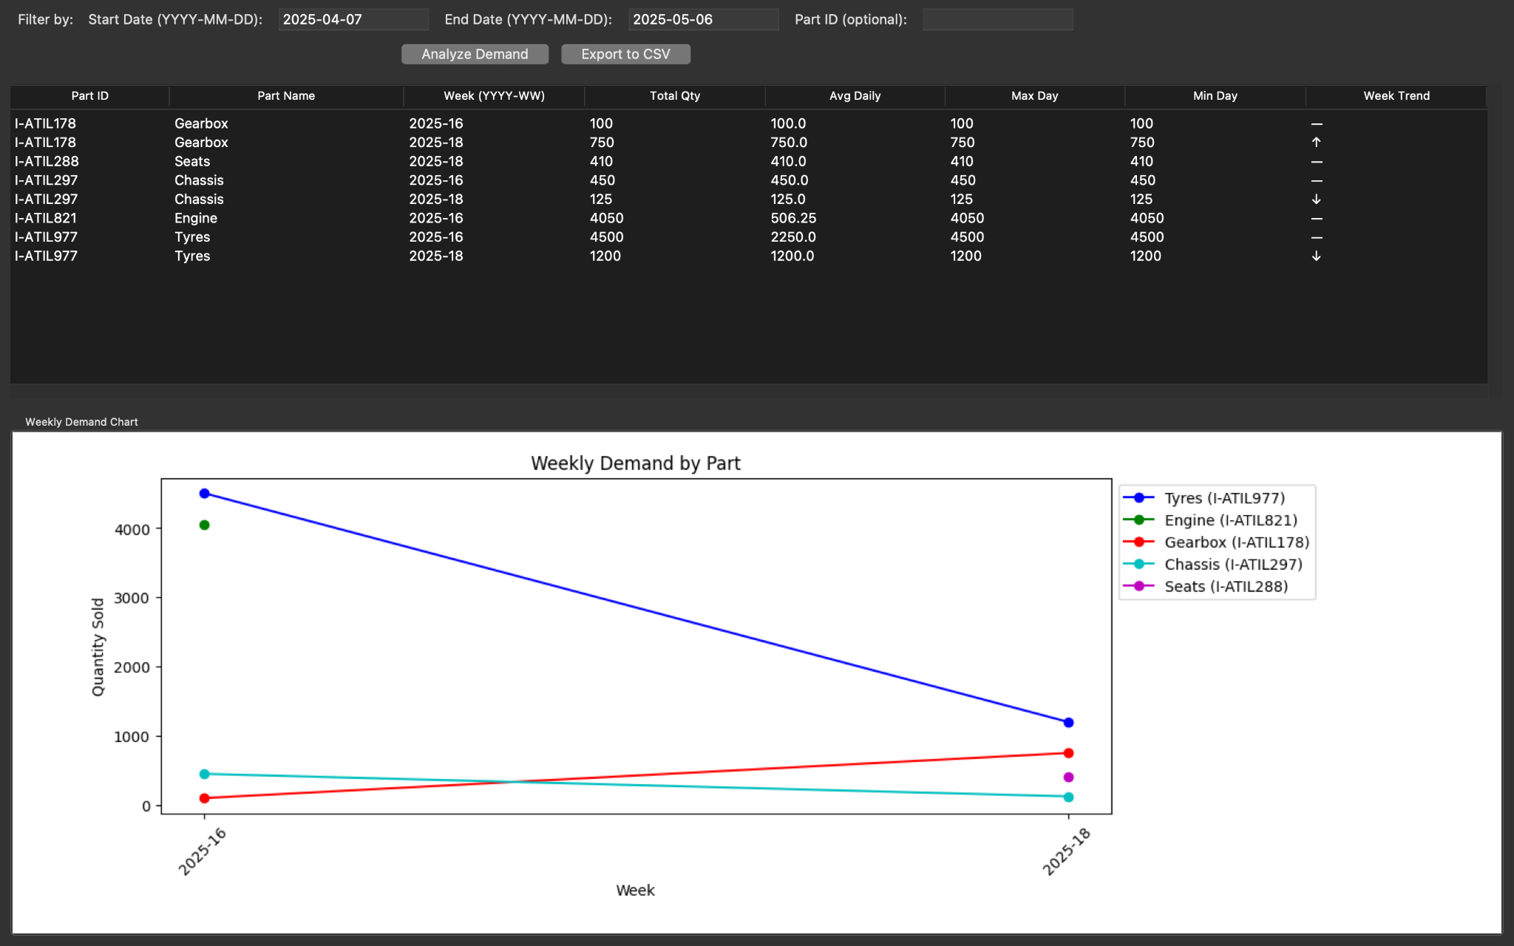

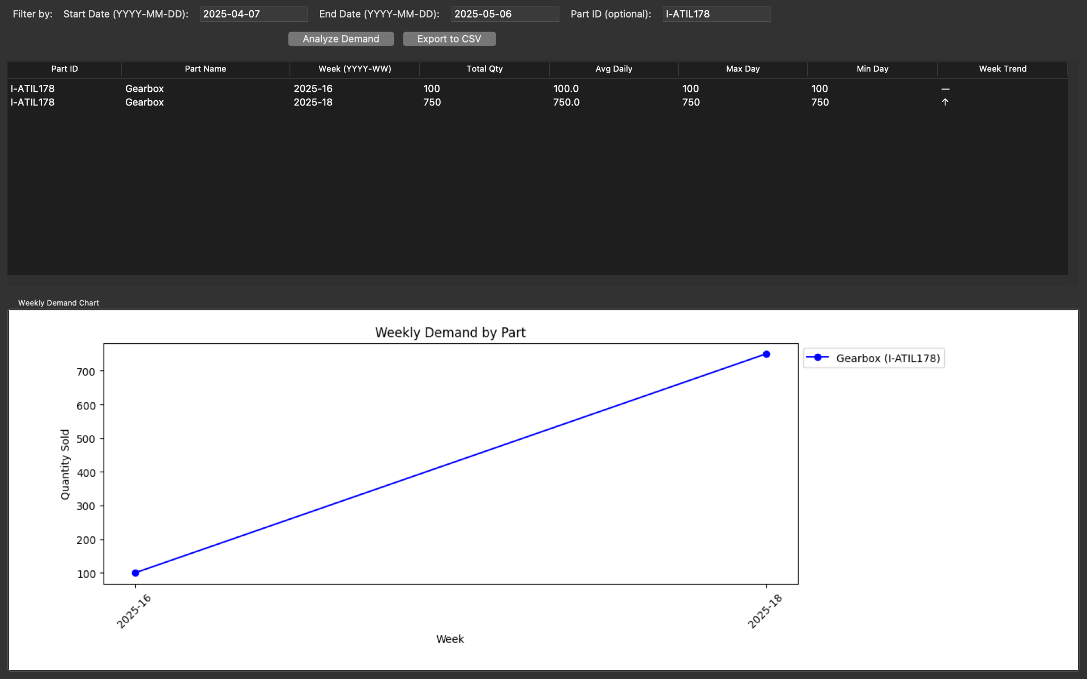

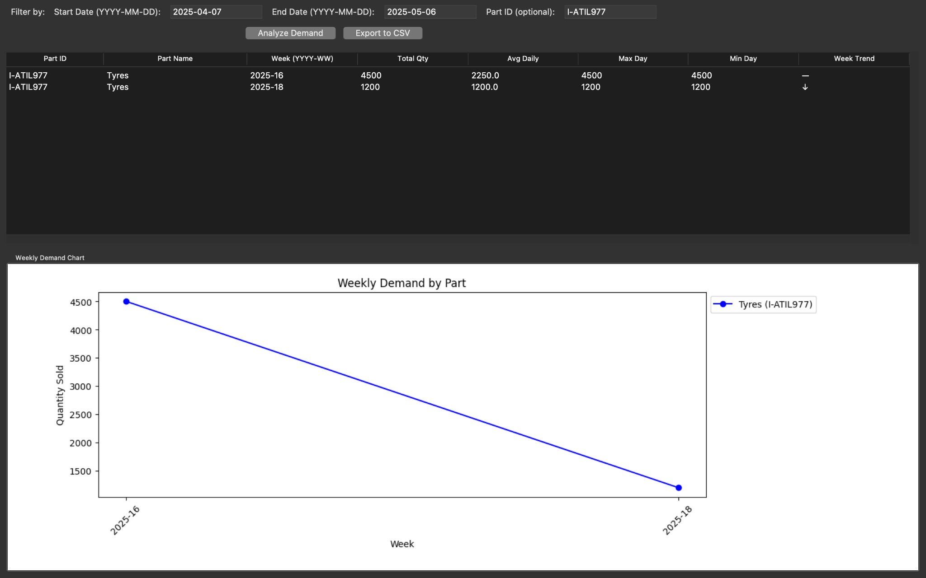

**draw_sales_chart()**: Creates visual representations of monthly revenue using matplotlib bar charts embedded in the Tkinter interface.

### **Audit Logging**

**add_audit_log()**: Records all significant system actions with current user information, timestamps, and detailed descriptions for accountability.

**view_audit_logs()**: Provides an interface for reviewing the audit trail with filtering capabilities by action type, user, and date, plus export functionality.

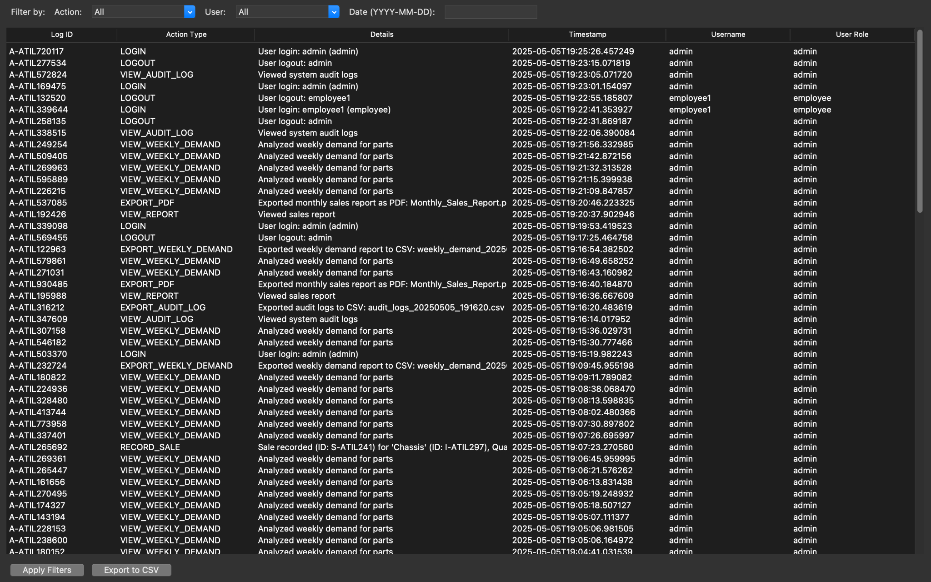

### **Testing and Development Tools**

**insert_sample_sales_data()**: Generates realistic test data across a 180-day period with random part selections, quantities, and dates to facilitate testing of reporting features.

### **User Interface**

**build_gui()**: Constructs the main application interface using Tkinter's notebook component to organize functionality into tabs:

* Inventory management tab (admin only)

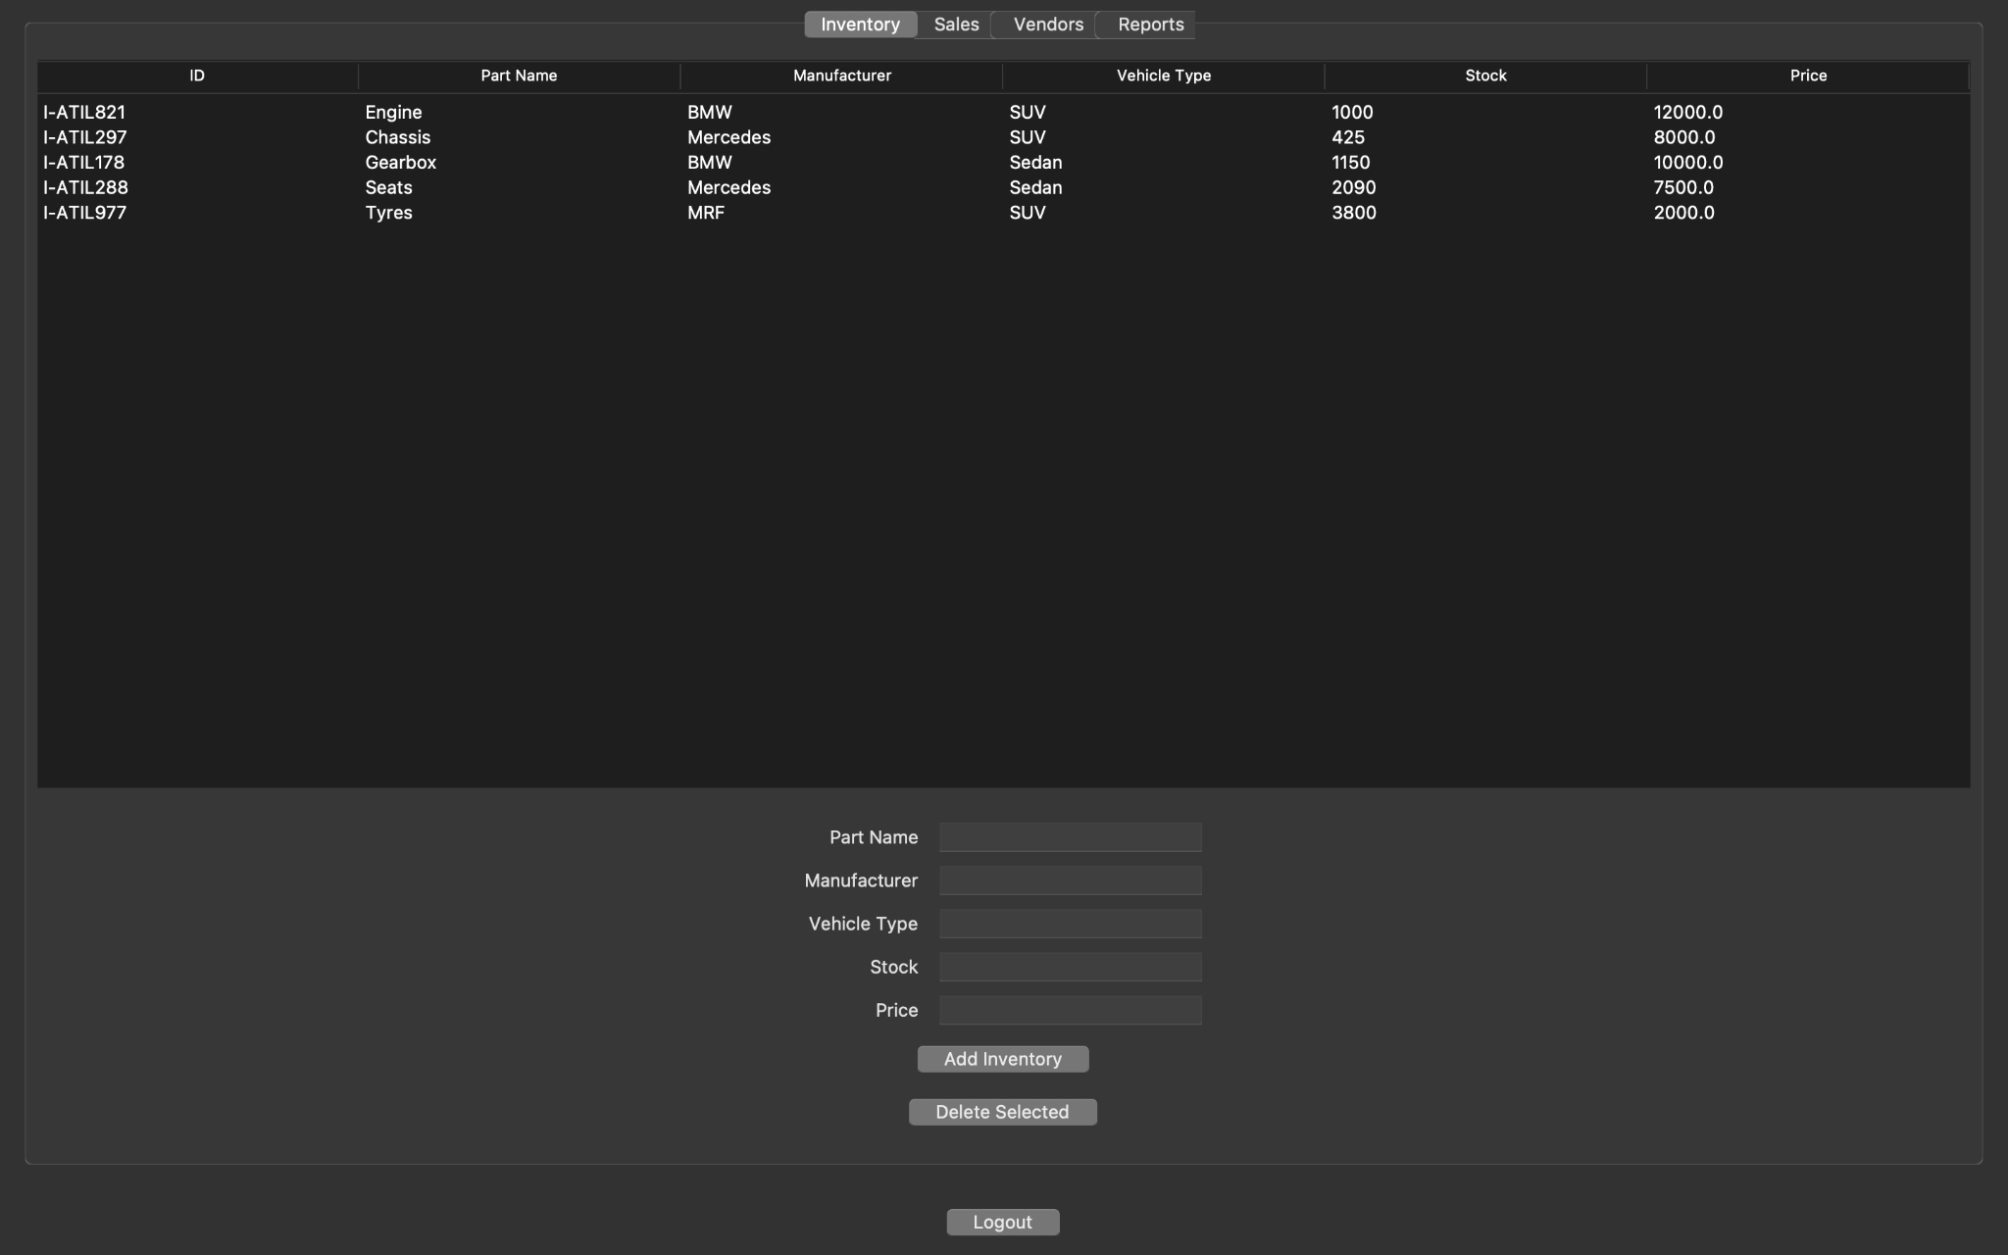

* Sales processing tab (all users)

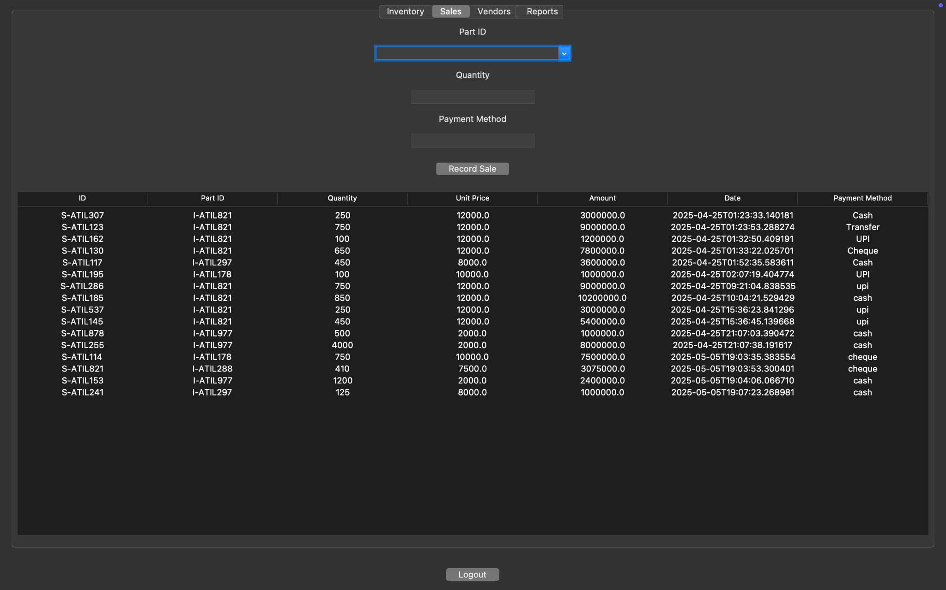

* Vendor management tab (admin only)

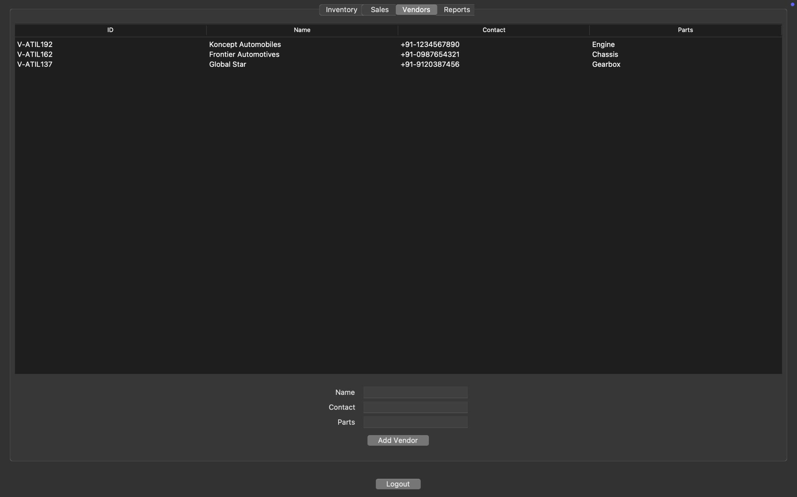

* Reports and analytics tab (admin only)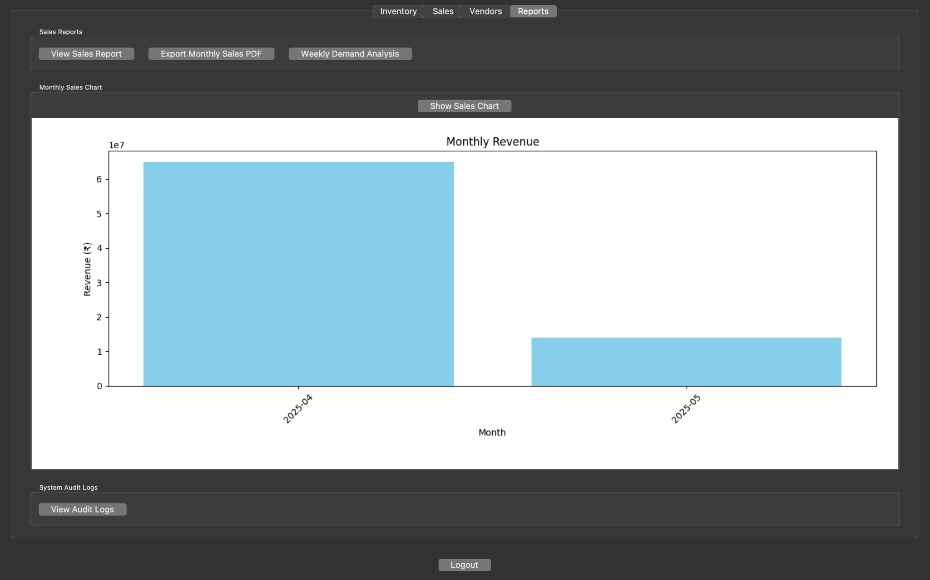

Each tab contains appropriate entry fields, tables, and buttons specific to its function.

## **Unit Testing**

The code includes a simple unittest framework that demonstrates testing practices:

**TestASPAS:** Validates inventory operations, stock updates after sales, and sale rejection when stock is insufficient. Ensures database state is reset before each test. Confirms correct format of auto-generated sale IDs.

Contributors

* Ashmit Gulati - 2210110212

* Tarunya Gautam - 2210110619

* Dev Misra - 2210110969

* Lakshya Mishra – 2310110163

*Ishan Chaudhary - 2210110307

---